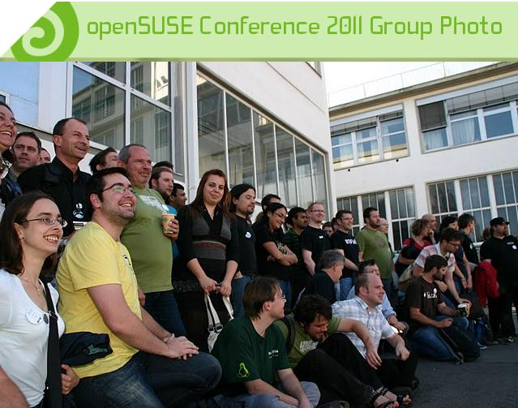
About openSUSE
The openSUSE project is a worldwide effort promoting the use of Linux everywhere. openSUSE creates one of the world's best Linux distributions, working together in an open, transparent and friendly manner as part of the worldwide Free and Open Source Software community.

The project is controlled by its community and relies on the contributions of individuals, working as testers, writers, translators, usability experts, artists, ambassadors and developers. The project embraces a wide variety of technology, people with different levels of expertise, speaking different languages and having different cultural backgrounds.

Have a lot of fun...

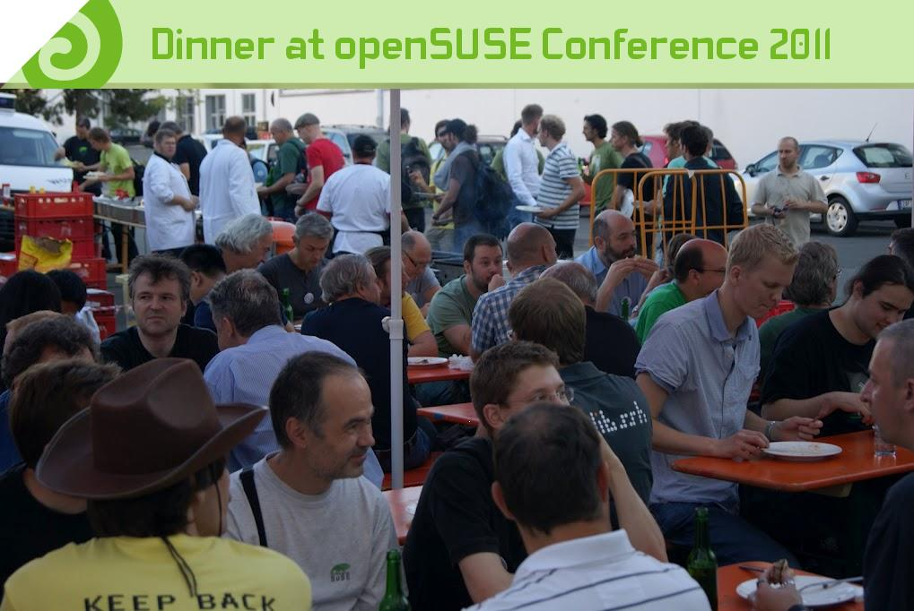
The openSUSE Summit 2012

2012 marks the first year that we are holding a conference in the Americas region. With the growth of the global openSUSE community a need for a 'cousin' to the successful European openSUSE conference in the Americas has risen. Co-located with SUSECon, the main conference of our parent sponsor, SUSE Linux, The openSUSE Summit will bring together the North- Central and South American community to meet face to face and collaborate on all things Open Source and openSUSE.

The Sujmmit aims to bolster the 'open' in openSUSE, bringing together openSUSE contributors and members of numerous other Open Source projects, both upstream like LibreOffice, Samba and GNOME as well as from other distributions like Fedora and Debian. This will create a rich environment for innovation, a place for ideas to grow!

Topics for the openSUSE Summit range from technical talks about packaging, Open Build Service and development tools to more community-oriented discussions about the future and direction of open source software.

Join us for 3 exciting days in Orlando, Florida for presentations, workshops and most importantly, fun and excitement.

Place and Date
The openSUSE Conference 2012 will take place in Orlando, Florida from September 21 to September 23 2012.

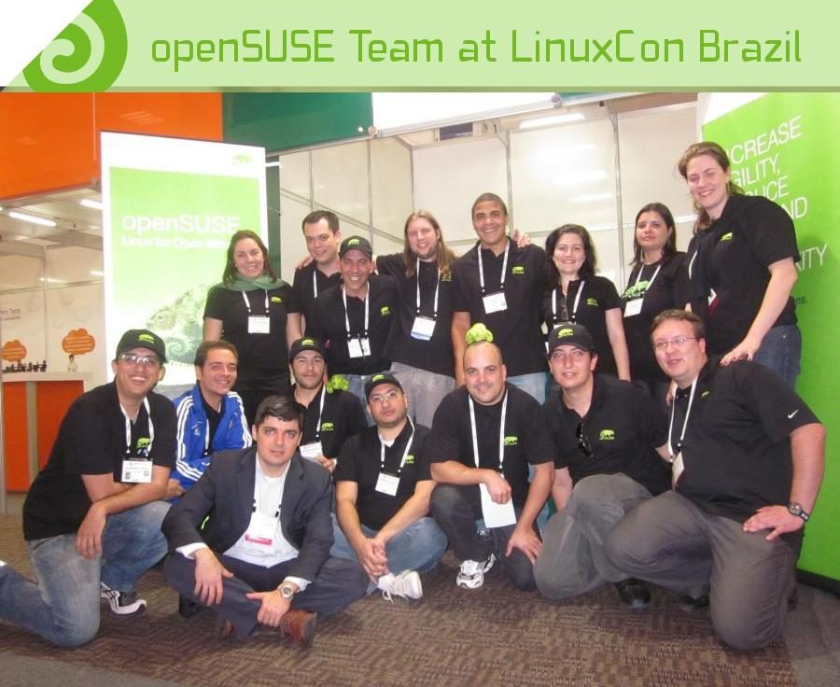
Conference Admission
We expect to welcome about 200 Open Source developers, testers, usability experts, artists and professional attendees. Admission to the openSUSE conference is free. However a professional attendee ticket is available that offers some additional benefits.

Professional pass gives you access to:
- All openSUSE sessions
- Networking session/speaker dinner
- Feedback session with SUSE executive management team
Cost: U.S. $350 or €250

Community pass
Is free and gives you access to all openSUSE sessions

Sponsorship Investment
By sponsoring this prominent event, you will gain excellent industry visibility, attract active community members to your organization and its work, and proudly support the open source community. Your sponsorship will be used to defray travel costs for speakers and attendees as well as facilities costs.
The following main sponsorship options are available:

GOLD
  - Can present up to two sessions*
  - Receive up to 15 total Professional entry tickets
  - Highlighted as Gold Sponsor on conference T-shirt
  - Logo appears in all Birds of a Feather (BOF) rooms
  - Receive all Silver sponsorship benefits
  - Becomes Silver Sponsor of the openSUSE community for 2013
Investment: U.S. $ 5,000 or € 3,500

SILVER
  - Can present one session*
  - Receive up to 10 total Professional entry tickets
  - Sponsor introduction at oSC kickoff
  - Highlighted as Silver Sponsor on conference T-shirt
  - Logo appears in main conference room
  - Receive all Bronze sponsorship benefits
  - Becomes Bronze sponsor of the openSUSE community for 2013
Investment: U.S. $ 2,500 or € 1750
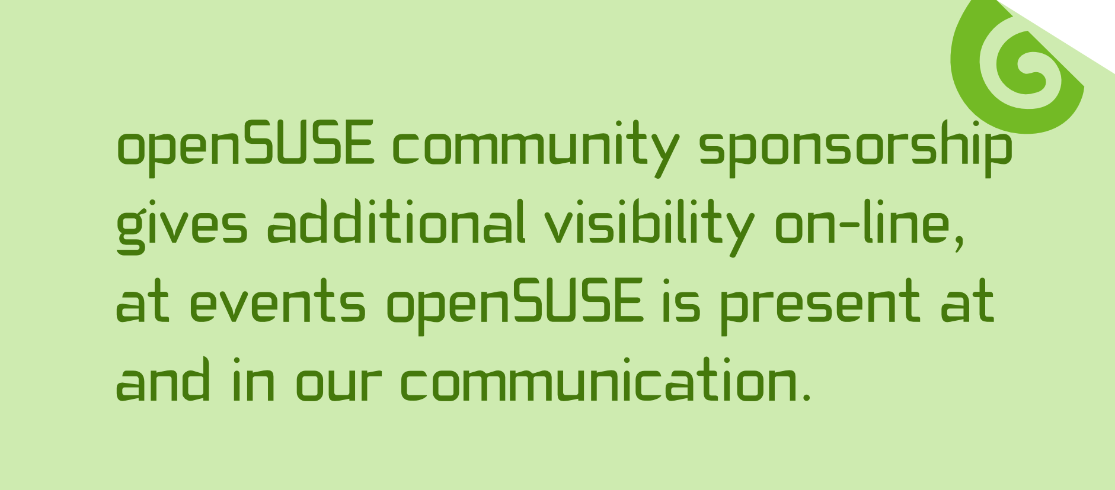

BRONZE
  - Up to 5 Professional entree tickets
  - Mention in all distributed materials
  - Company logo placement on banner in main hall
  - Recognition in the closing session
  - Ability to provide goodies in the conference bag (at sponsor's expense)
  - Opportunity for a joint press release with openSUSE/SUSE Labs conference
Investment: U.S. $ 1,250.00 or € 875

SUPPORTER
  - Show your support for openSUSE and the openSUSE Conference!
  - Receive 2 Professional entree tickets
  - Logo appears on the sponsorship page
Investment: U.S. $ 800.00 or €560

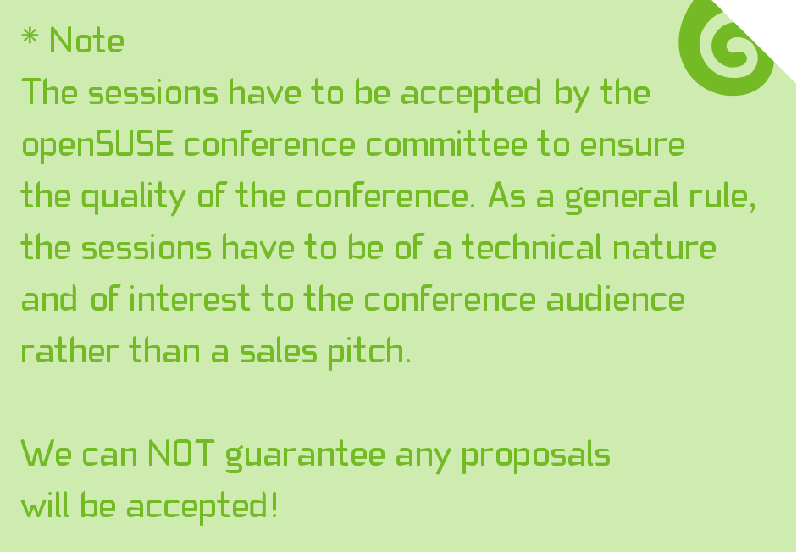

Partners
Besides the general sponsorships, we are offering a few partnership options to allow you to bring our community some fun items, including ice cream, coffee and lunches. If you sponsor any of these, your logo and name will be connected to the services and of course your logo will be part of the partner section of our promotional materials.
A partnership package can be taken separate or in combination with a main sponsorship package, in which case we give a discount on the partnership costs. An option "with sponsorship" shows the additional costs on top of the main sponsorship. The "without sponsorship" is the price for a partnership without a Bronze, Silver or Gold sponsorship.

BLACK GOLD PARTNERSHIP
The Black Gold Partnership allows the partner to supply a set number of free coffee/tea tickets to the attendees of the conference each day. Depending on the number of tickets per attendee and other sponsorship options, the costs range from $2,000 to $7,000.

tickets | Without sponsorship | With sponsorship
2 | $2500 (€1750) | $2000 (€1400)
4 | $5000 (€3500) | $4000 (€2800)
8 | $7000 (€4900) | $6000 (€4200)

HIGH NOON REFRESH PARTNER
This partnership is for companies wishing to have their brands highlighted by providing daily lunch tickets to the attendees.

Without sponsorship | With sponsorship
$5000 (€3500) | $4000 (€2800)

KICK BACK PARTNERSHIP
It's party time! This partnership is for any company which aims to support the 'Lizard Lounge' party organized for the attendees of the conference. The company's brand will be prominently displayed at the party location.

Without sponsorship | With sponsorship
$6000 (€4200) | $5000 (€3500)

BRAIN FREEZE PARTNERSHIP
This partnership gives your company the possibility to inspire our attendees with some fresh ice cream tickets.

tickets | Without sponsorship | With sponsorship
1 | $2500 (€1750) | $2000 (€1400)
2 | $5.000 (€3500) | $4000 (€2800)

All partners will be recognized
in the closing session.

For questions please contact:
Izabel Cerqueira Valverde
Sponsorship manager
openSUSE Conference Organization
e-mail izabelvalverde@opensuse.org
phone +55 118 510 4280

We appreciate your attention and hope to have you with us!

Images courtesy of Pascal Bleser
Brochure Artwork: Kamila Součková and Andes Silva

